Iteration 3: Addressing Quality Attribute Scenario Driver (QA-3)

In this section, we are building on the fundamental structural decisions made in the previous iterations. We can reason about the fulfillment of one of the most important quality attributes: this iteration focuses on quality attribute scenario QA-2 (Availability).

Step 2: Establish Iteration Goal by Selecting Drivers

For this iteration, the focus is on the QA-2 (Availability) quality attribute scenario. The system should keep functioning in case of a failure within a short period of time.

Step 3: Choose One or More Elements of the System to Refine

In this availability scenario, the elements that will be refined were identified during the first iteration:

* Application server
* Database server

Step 4: Choose One or More Design Concepts That Satisfy the Selected Drivers

|  |  |
| --- | --- |
| Design Decisions and Location | Rationale and Assumptions |
| Active redundancy is introduced by replicating the application server and other critical components such as the database | The functionality of the system will not be affected in case of a failure when the critical parts are replicated. |
| Create backup servers for both the application server and the database server | By having backups of the servers the system can be easily restored in case of an error. |

Step 5: Instantiate Architectural Elements, Allocate Responsibilities, and Define Interfaces

|  |  |
| --- | --- |
| Design Decisions and Location | Rationale |
| Use active redundancy and load balancing in the application server | Since there are two servers that are copies of each other are running at the same time, it is recommended to distribute the load between two servers so that the system can perform in an efficient way. |

Step 6: Sketch Views and Record Design Decisions

The figure below shows the updated deployment diagram that introduces the active redundancy and load balancing.

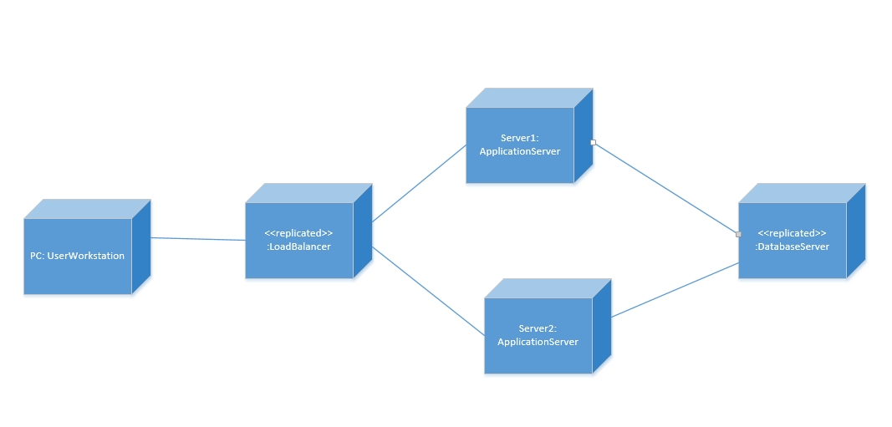

|  |  |
| --- | --- |
| Element | Responsibility |
| LoadBalancer | Balances the load of requests coming to the main application server |
| Server2:ApplicationServer | The copy of Server1: ApplicationServer. It helps balancing the load and it operates in case of a failure that might happen in Server1: ApplicationServer. |

Step 7: Perform Analysis of Current Design and Review Iteration Goal and Achievement of Design Purpose

|  |  |  |  |
| --- | --- | --- | --- |
| Not Addressed | Partially Addressed | Completely Addressed | Design Decisions Made During the Iteration |
| UC-2 |  |  | No relevant decisions made. |
| UC-3 |  |  | No relevant decisions made. |
| UC-4 |  |  | No relevant decisions made. |
| UC-5 |  |  | No relevant decisions made. |
|  |  | QA-2 | The load balancer is introduced as well as a replica of the application server. By using a load balancer we are dividing the requests coming to the server. Also, replicated server keeps the system functioning in a short period of time which improves the availability. |
|  |  |  |  |